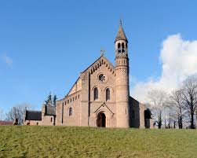
Christmas Masses
St. Michael’s Church, Lissan.
Please Note: In our efforts to continue safeguarding our community, attendance at
The Christmas Eve 5pm and 7pm masses will be by ticket only.
To obtain tickets please ring : 028 86764581 (Daytime Mon-Fri) 02886763674 (Evening & weekends)
Christmas Eve  Friday 24th December 2021  (ticket only) | 5.00 p.m.
Christmas Eve  Friday 24th December 2021  (ticket only) | 7:00 p.m.
Christmas Eve  Friday 24th December 2021 | 9:00 p.m.
Christmas Day  Saturday 25th December 2021 | 11:00 a.m

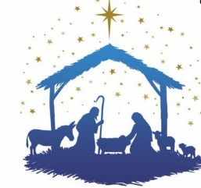
Please note: These arrangements may be subject to change pending Government restrictions)

