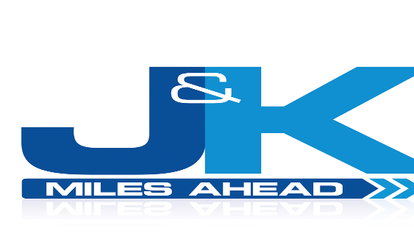

Please see below, some guidance for home to school transport services. These points are reviewed and updated on a regular basis.

- We have no requirements for social distancing on our coaches. We do however encourage those from the same family and class groups to sit together.
- When in your seat, please remain in it for the duration of the journey. We also request that passengers use the same seat each day.
- Seats must be filled from the back first. When possible, we will be disembarking passengers from the front of the coach first.
- Face coverings are not compulsory on vehicles for school children, although we strongly encourage these to be worn. Any teaching staff accompanying pupils on the coach in the event of a trip or outing will be required to wear a face covering also.
- Hand sanitizer is provided at the entrance of the coach. Please ensure this is used upon entering and leaving the coach.
- All coaches are deep cleaned on a daily basis. All frequent touch points are sanitized regularly throughout the day.
- We have procedures in place if a passenger becomes symptomatic. Full details of this procedure can be found in our risk assessment, which is available upon request.
- We ask that all pupils and staff please respect and follow the guidance we have in place and in addition to this, any instructions requested by our driver.

Yours Sincerely,

Jim Quinn
Company Director
Copyright © 2020 J&K Coaches Ltd. All rights reserved.

