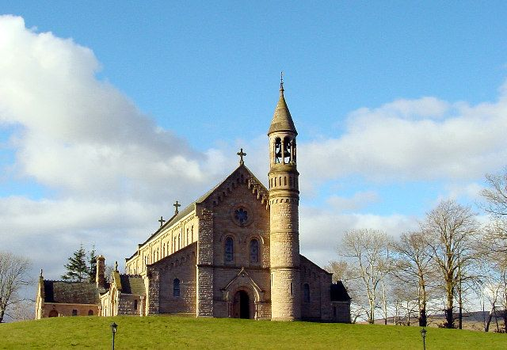
Invitation for
Primary 4 pupils

Primary 4 Pupils & Parents -
You are invited to join Fr. McGinley via the online webcam on
Saturday 2nd May 2020 @ 7:30 p.m.
to partake in a short service for
your previously arranged First Communion Day.
Please log into:
mcnmedia.tv/camera/st-michaels-lissan

