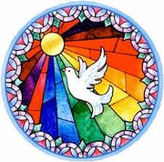Service of Light

[**https://www.mcnmedia.tv/**](https://www.mcnmedia.tv/)

**Friday 24th April @7.30pm**

