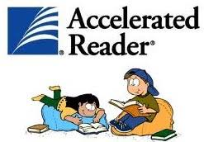
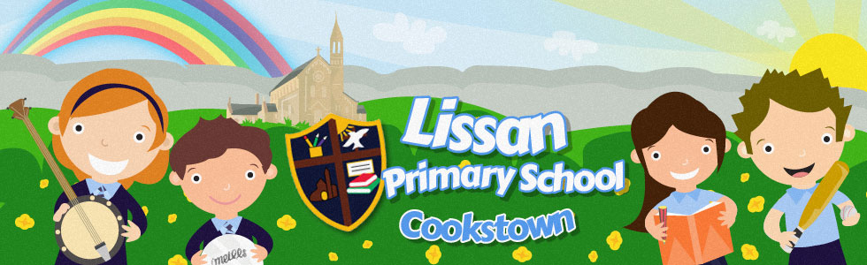
Mon 20th April 2020
Accelerated Reading Target Achievers
- Congratulations to the pupils listed below who have reached their AR targets. (Your new targets will be reset.)
- We will keep a record of your achievements to ensure you receive your rewards when school reopens.
- Many of you are very close to reaching your targets so please keep up with your daily reading.
- We look forward to seeing your name on next week’s list.
- Remember to access the websites below if you need reading materials.
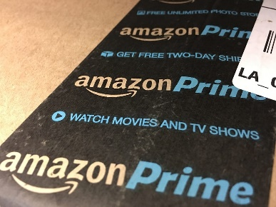
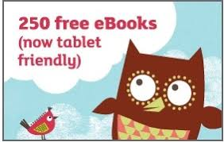
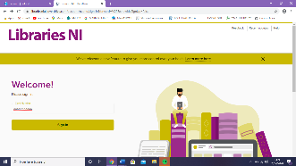
P.2 | Patrick O’Neill
P.3 | Aoibh McCrory
P.3 | Dylan McCrory
P.4 | Cara Conway
P.6 | Thomas McGlade
P.7 | Anna Rose McGuckin
Help with reading
@ Lissan Primary School
- Accelerated Reading
https://ukhosted53.renlearn.co.uk/2235110/
(*For taking quizzes on books read )
________________________________________________________
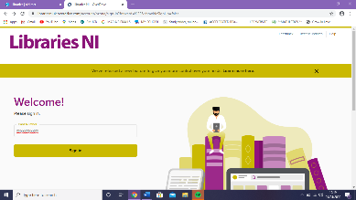
- NI libraries ebooks

https://www.librariesni.org.uk
Libraries NI offers free ONLINE eBooks and eMagazines.
There are 48,000 items and 11,500 titles in the eBooks catalogue. There are no fines for late return of eBooks as they simply expire (end) at the end of the loan period.
*You will need to have your child’s Library card details to log on.
___________________________________________________________________
- Oxford Owl
https://www.oxfordowl.co.uk
(*Log into Oxford Owl for HOME)

Explore by age:
3–4 4–5 5–6 6–7 7–8 8–9 9–10 10–11

Free eBook library
Take a look at our tablet-friendly eBooks, which include all of your child’s favourite characters from Biff, Chip and Kipper to the Project X team.
Browse eBooks
______________________________________________________________________________________
- Amazon Prime

https://www.amazon.co.uk

*Anyone who subscribes to Amazon Prime – 2 months free use of kindle unlimited

*Amazon is giving away kids’ films, TV shows, books and education apps FREE for a month
_________________________________________________________________________________________
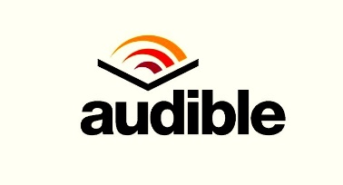
- Audible

stories.audible.com
*Good news for those stuck at home in isolation: Audible is making hundreds of titles available for free during the coronavirus pandemic.
*The audiobook platform has said that, for as long as schools are closed, anyone can listen to a vast selection of its titles.
*Simply visit stories.audible.com from any web browser . No log-ins, credit card or passwords needed.
*There are stories for tiny tots, big kids, parents and everyone in between. It's all part of the global effort to pull together and support children at this time so they can, as Audible put it: "Continue dreaming, learning, and just being kids."
___________________________________________________________
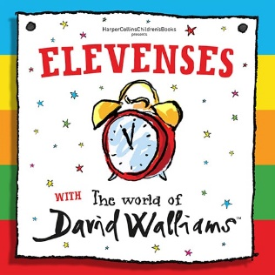
- Elevenses with
David Walliams

https://www.worldofdavidwalliams.com/elevenses/
* free audio story every day for 30 days

- Nessy

https://www.nessy.com

* Nessy programs are designed to help students of all abilities learn to read, write, spell and type, especially those who learn differently, including:
- Mainstream
- EAL
- Homeschool
- Students with dyslexia
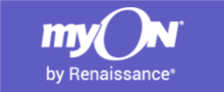
_________________________________________________________________________
- myOn
https://readon.myon.co.uk/library/browse.html
* myOn – can read books but cannot directly quiz.
*You can also take myON quizzes on Accelerated Reader.
