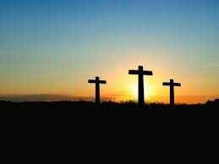
Easter

https://www.mcnmedia.tv/

Holy Thursday 8pm
Good Friday
Stations of the Cross 3pm
Passion 8pm

Easter Vigil Holy Saturday 8pm

Easter Sunday 11am

