Help with Numeracy

There are lots and lots of excellent Numeracy based websites available. These are the ones we think are the most useful.

<https://www.mathletics.com/uk/>

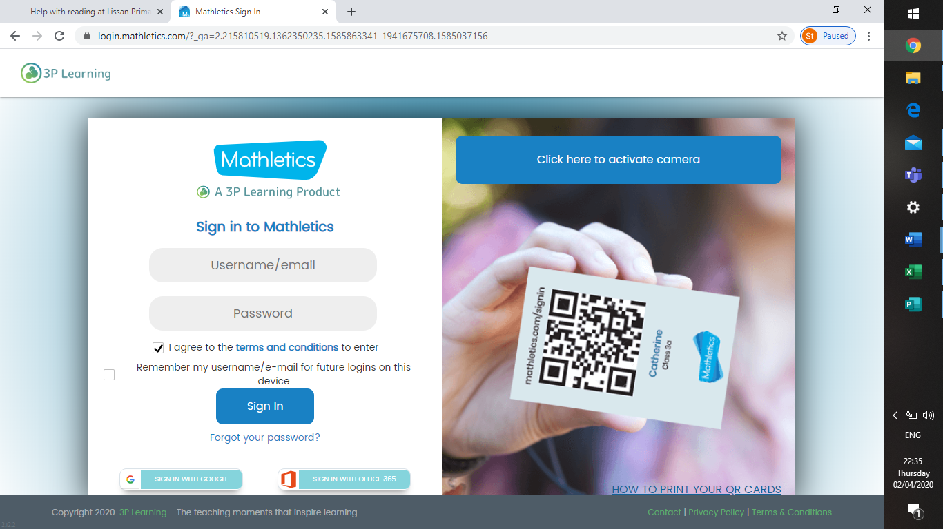

* Mathletics provides a safe, encouraging learning environment to help your child grow, gain confidence, and achieve their best.
* All pupils have their own login details – if your child has misplaced theirs please contact your class teacher for support (emails below)
* We have also added a “Parent’s Guide” in “Home Learning” for additional information.

<https://www.mathsweek.ie/2019/maths-at-home-activities/>

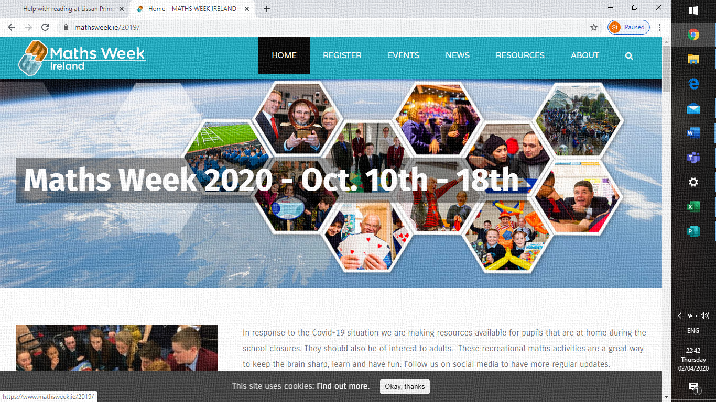

 These recreational maths activities are a great way to keep the brain sharp, learn and have fun.

<https://www.mathschase.com/>

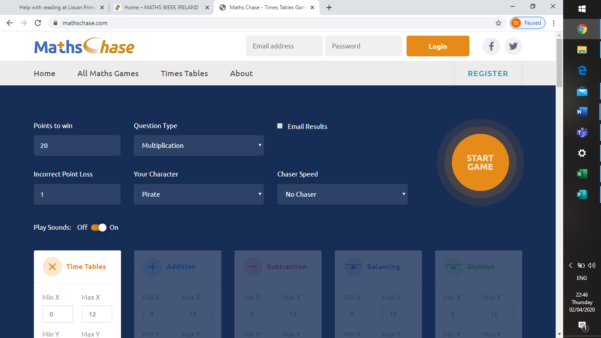

**Maths Chase** provides free maths games to help students learn. Your child can test times tables, addition and other maths skills in a fun and engaging way.

<https://www.edgehill.ac.uk/educationpartnership/linkstolearning/>

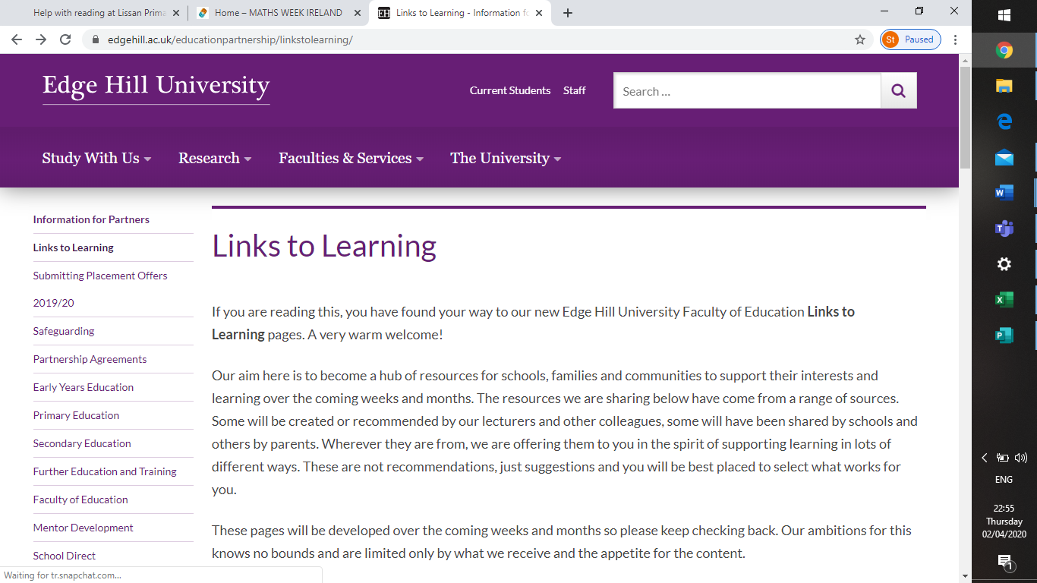

The site provided by Edge Hill University is a hub of resources to support your child’s interests and learning over the coming weeks and months. The resources have come from a range of sources and cover all aspects of the curriculum.

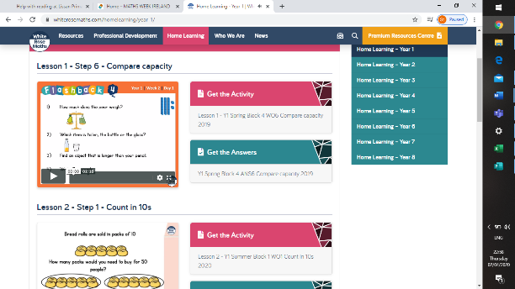

A fantastic site that provides support for all ages!

<https://www.studyladder.com/>

**Studyladder** is an online literacy & mathematics learning tool. Pupils from P4-7 have their own login details, if they have misplaced these please contact your class teacher using the email addresses listed below.

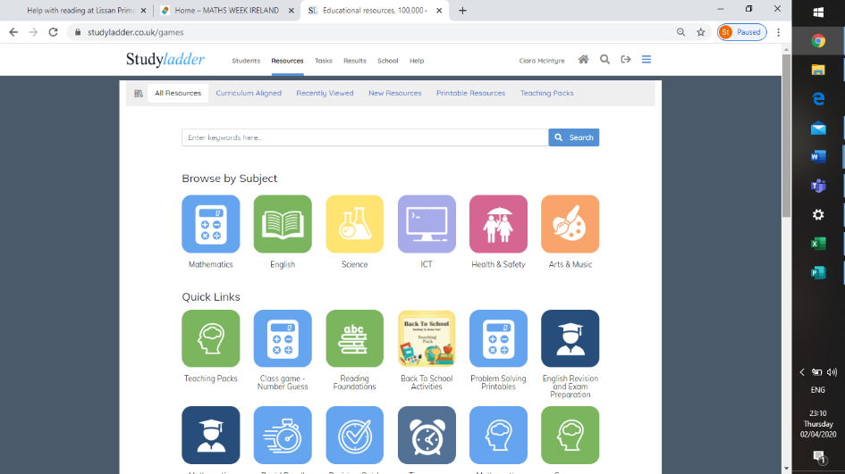

Mrs McIntyre – [cmcintyre695@c2kni.net](mailto:cmcintyre695@c2kni.net)

Mrs Coyle – [mcoyle358@c2kni.net](mailto:mcoyle358@c2kni.net)

Mrs Hagan – mhagan339@c2kni.net

Mrs Donnelly – [sdonnelly118@c2kni.net](mailto:sdonnelly118@c2kni.net)

Miss Devlin – [mdevlin514@c2kni.net](mailto:mdevlin514@c2kni.net)